  - 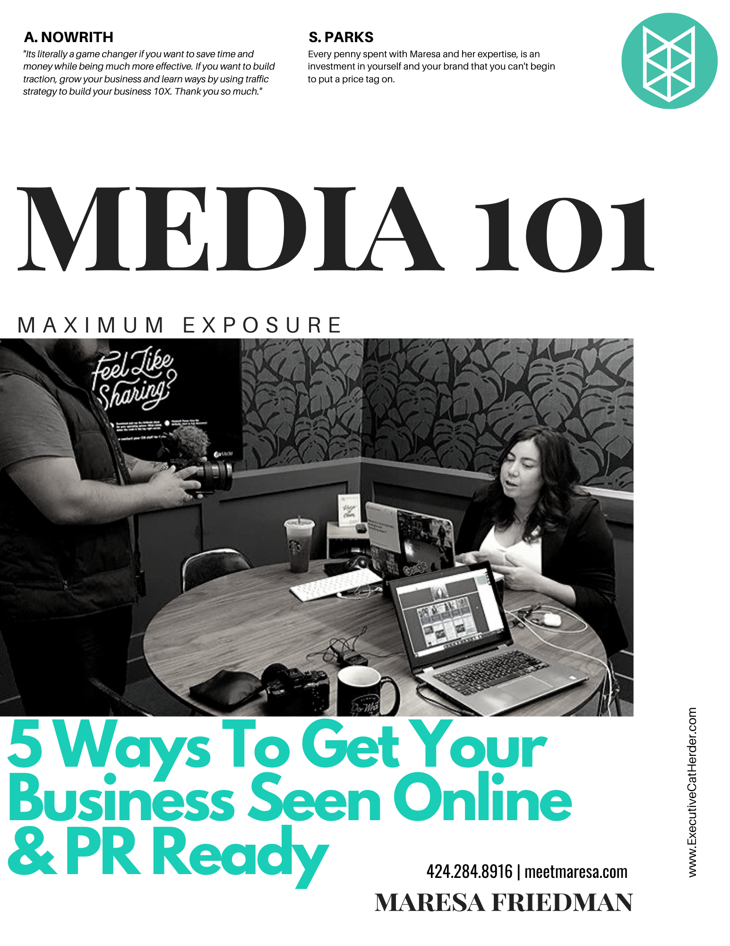

Solution Brainstorming Worksheet
Use this worksheet as a checklist and planner for optimizing and branding your website.
My Brand | My Brand Fonts and Colors |  | My Anchor Text Colors
I have set up and optimized the following | I have shared my choices with relevant team members and contractors |  | Link colors within my website
- Unique logo  - Color palette  - Tagline  - Mission Statement  - Professional head shot  - Other Elements  __________________  __________________  __________________ | Headlines  Font__________________  Size ___pt  Color:  RGB:___ ___ ___  HEX: #_______ |  | Unvisited Link  Font__________________  Size ___pt  Underline?  Yes No  Color:  RGB:___ ___ ___  HEX: #_______  Visited Link  Font__________________  Size ___pt  Underline?  Yes No  Color:  RGB:___ ___ ___  HEX: #_______  Background color  RGB:___ ___ ___  HEX: #_______
Sub-heads
Font__________________
Size ___pt
Color:
RGB:___ ___ ___
HEX: #_______

Body Text
Font__________________
Size ___pt
Color:
RGB:___ ___ ___
HEX: #_______

My Tag Line |  | My mission statement
My short bio |  | My long bio

WEBSITE CHECKLIST
- Home Page
- Landing Page
- About Page
- Contact Page
- Media Page
- Web Contact form
- Email sign-up form
- TESTIMONIALS

Awards: | Certifications: | Appearances in mainstream media:
RICH MEDIA CONTENT
- Home Page
- Landing Page
- About Page
- Contact Page
- Media Page

Tasks to outsource, delegate or do myself:
Guests I ….
…have interviewed: | …wish to interview: | …wish to feature:

